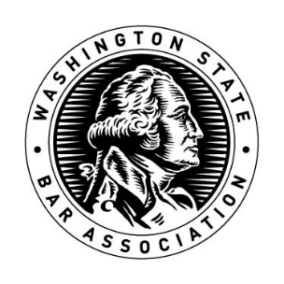

Authorization and Waiver for Disciplinary Records check to supplement application for the Commission on Judicial Conduct.

You are hereby authorized to release and forward immediately to the WSBA Volunteer Engagement Advisor all information contained in my disciplinary record, whether currently public or nonpublic. I authorize this information to be disclosed to the WSBA Board of Governors. If I am appointed to the Commission on Judicial Conduct, I authorize this information to be disclosed also to the Commission on Judicial Conduct.

Signature:
Date:
Printed Name:
WSBA #:

Please sign and email to barleaders@wsba.org. This form must be received before May 19, 2023, to ensure your application will be considered by the WSBA Board of Governors Nominations Committee.

