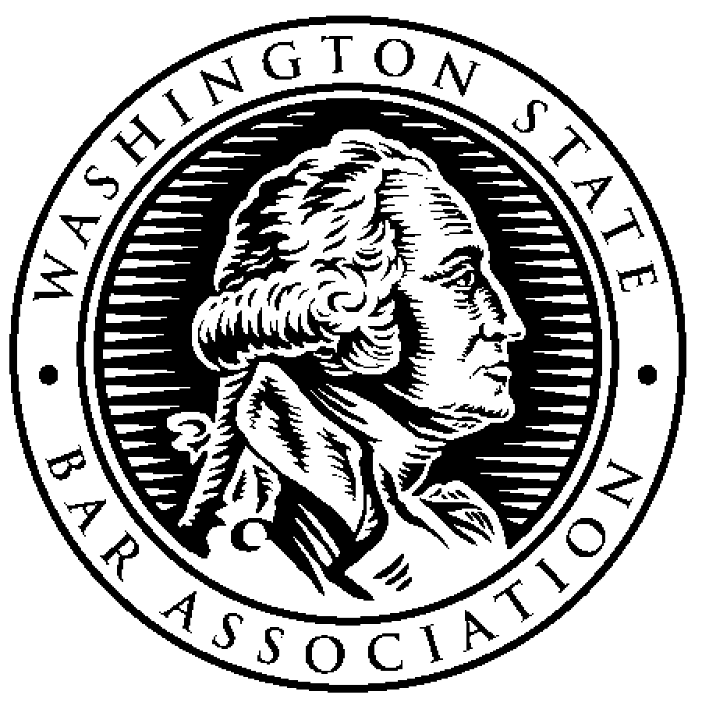**Administrative Law Section**

*of the Washington State Bar Association*

Monthly Meeting DRAFT Agenda, April 19, 2020

1. Approval of Minutes from March 22, 2021 (all)
2. Approval of Agenda (all)
3. Financial update (Katy Hatfield)
   1. Investment of section funds? (Katy/Richelle)
4. Committee updates
   * + - 1. Retreat (Margie Gray)
         2. Legislative (Richard Potter)
         3. Publications and Practice Manual (Selina Kang/Richelle Little)
         4. CLE (Bill Pardee)
         5. Diversity and Outreach (Alexis Gobeske/Robert Rhodes)

Mentorship Program

* + - * 1. Homan Award (Lea Dickerson)
        2. Newsletter (Ed Pesik)
        3. Nominations committee (Eileen Keiffer)

1. Recovery Task Force – Appellate Committee (Eileen Keiffer/Richard Potter)
   1. Proposal to promote Direct Appeals of APA Appeals to Court of Appeals under RCW 34.05.518.
2. Good of the Order
3. Next Meeting – May 17, 2021, noon (Eileen Keiffer)