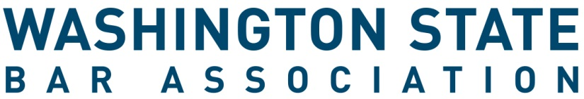

Board of Governors Congressional District - Application Form

All Application materials must be received by 5 p.m. PST on Wednesday, February 15, 2023.

INSTRUCTIONS
- Review all information regarding board service, the application and the election processes online here.
- Complete this application form. If you are nominating someone else, ask them to sign it below.
- Complete other requested materials, see website for more information.
- Letters of Support (if desired) can be submitted with your materials or separately. Letters of support should be emailed to barleaders@wsba.org no later than Wednesday, February 15, 2023.
- Email the signed form and materials to barleaders@wsba.org. Applications must be received by 5 p.m. PST on Wednesday, February 15, 2023. Late materials will not be accepted.
- Questions? Contact Paris Eriksen at parise@wsba.org or barleaders@wsba.org
_____________________________________________________________________________________

Applicant Information
Name | Click or tap here to enter text.
WSBA Bar # | Click or tap here to enter text.
Congressional District You are Apply For | Choose an item.
Email Address | Click or tap here to enter text.
Phone Number | Click or tap here to enter text.

Candidate for position on the Washington State Bar Association Board of Governors

I, the undersigned Active member of the Washington State Bar Association, am running for the office of Governor from Choose an item..

Name of Candidate (please print) WSBA Bar #

Signature of Nominator (if relevant) WSBA Bar #

Signature of Candidate

The WSBA values diversity and inclusion, and encourages Black, Indigenous and people of color, women, people from the LBGTQ communities, people with disabilities, and members of other groups who have been systemically oppressed to apply for our committees, boards, and panels. This process is administered by the Office of the Executive Director. Submit the application form and all materials to WSBA no later than 5 p.m. PST on February 15, 2023. Filing may be accomplished by emailing the scanned form to barleaders@wsba.org. For questions, please email Volunteer Engagement Advisor, Paris Eriksen, at parise@wsba.org.

