Washington State Legislature
Legislative Building

Olympia, WA 98504-0600

May 4, 2020

The Honorable Jay Inslee
Governor
State of Washington
Legislative Building
Olympia WA 98504

Dear Governor Inslee:

We are in receipt of your letter dated April 30, 2020 requesting extension of the statutory waivers and suspensions ordered in Proclamations 20-15.1, 20-20.1, 20-21.1, 20-23.2, 20-26.1, 20-27.1, 20-28.1, 20-29.1, 20-30.1, 20-31.1, 20-32.1, 20-33.1, and 20-34.1.

Pursuant to RCW 43.06.220(4), we hereby extend the statutory waivers and suspensions cited in Proclamations 20-15.1, 20-20.1, 20-21.1, 20-23.2, 20-26.1, 20-27.1, 20-29.1, 20-30.1, 20-32.1, and 20-34.1 until May 31, 2020.

The statutory waivers and suspensions cited in Proclamation 28.1 are extended until May 31, 2020, except for RCW 42.56.520(i) which is extended to May 11, 2020.

The statutory waivers and suspensions cited in Proclamation 33.1 are extended until May 11, 2020.

Senator Billig and Speaker Jinkins support extending the statutory waivers and suspensions cited in Proclamation 20-31.1 but Senator Schoesler and Representative Wilcox do not. Accordingly, as RCW 43.06.220(4) requires the agreement of all four caucus leaders, this request for extension is denied.

Additionally, Senator Billig and Speaker Jinkins support extending the statutory waivers and suspension for the time periods requested in your letter but Senator Schoesler and Representative Wilcox do not. Accordingly, as RCW 43.06.220(4) requires the agreement of all four caucus leaders, the time period for extensions has been limited.

Sincerely,

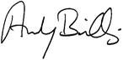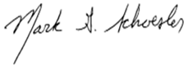

ANDY BILLIG MARK SCHOESLER
Senate Majority Leader Senate Minority Leader

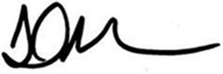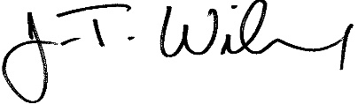
LAURIE JINKINS J.T. WILCOX
Speaker of the House House Minority Leader

