Lawyers In The Classroom
CONSTITUTION DAY LESSON PLANNING GUIDE

Your visit at-a-glance
Plan for 50 usable minutes — most periods are scheduled for 60 minutes on paper but settling in and end-of-period wind-down eat into that. The chart below shows how those minutes break down across the key phases of your visit. The full agenda and guidance for each phase follows.
Note: Only have 45 minutes? Trim your introduction and the framing — not the activity. The main event is where students will remember you.
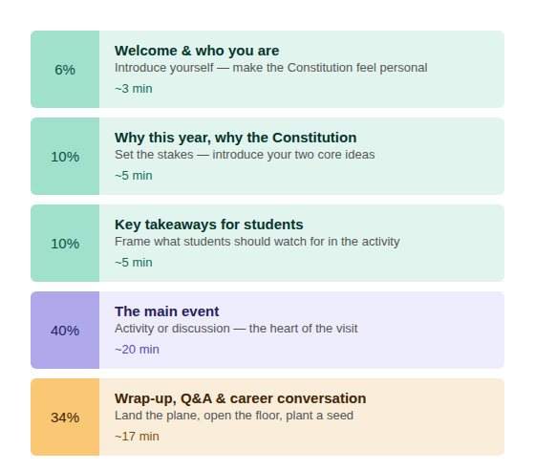

Navigating the classroom

DO’S:  - Set expectations upfront. Kids crave boundaries. If the teacher hasn't already, spend the first 2 minutes setting 2–3 simple ground rules (e.g., "Raise your hand to speak," "Listen when others speak").  - Speak in plain, punchy language. Translate legal concepts into analogies they care about — a contract breach is a broken promise to a friend; intellectual property is who owns a video game skin.  - Pivot when you lose the room. Glazed eyes or rising chatter? Abort the lecture. Ask a question, try a turn-and-talk (60 seconds, classmates turn to whoever's sitting next to them), or call on a student to summarize. For younger rooms, a 60-second brain break works too — stretch arms wide like the stripes on a flag, then reach up for the stars.  - Move around. Walk the aisles while you talk. Standing behind a desk creates distance that invites distraction.  - Give yourself a timer. A countdown on your phone or the board keeps you on track and gives students a heads-up before transitions. Both of you will thank you for it. | DON’TS:  - Don't count on the room going quiet for you. Before you start: ask the teacher what quiet-signal the class already uses.  - Don't lecture for more than 7 minutes straight. Break it up with a question, a scenario, or a quick activity. Back-and-forth beats monologue every time.  - Don't forget whose room it is. If something's off, the teacher will step in to handle it — and that's a good thing.  - Avoid legalese. If you use precedent, liability, or brief, define it immediately in plain terms. One sentence is all it takes.  - Don't debate a student. If someone gets combative, acknowledge them briefly ("good point to dig into"), say you'll follow up after class, and move on. Don't take the bait.  - Don't race. Silence is a tool. A pause after a question gives students time to think — resist the urge to fill it.

Pro-tip: Want to dig deeper – a veteran educator breaks down these dynamics in real-time: My 5 Cs of Classroom Management (Edutopia).

