Lawyers In The Classroom
CONSTITUTION DAY LESSON PLANNING GUIDE

Your journey at-a-glance
The visual flowchart below shows key touchpoints of your planning journey. You've made contact with your school or teacher, have a class and a date confirmed for your visit. From here, planning splits into two tracks depending on one thing: whether the teacher handed you a lesson or left it up to you.

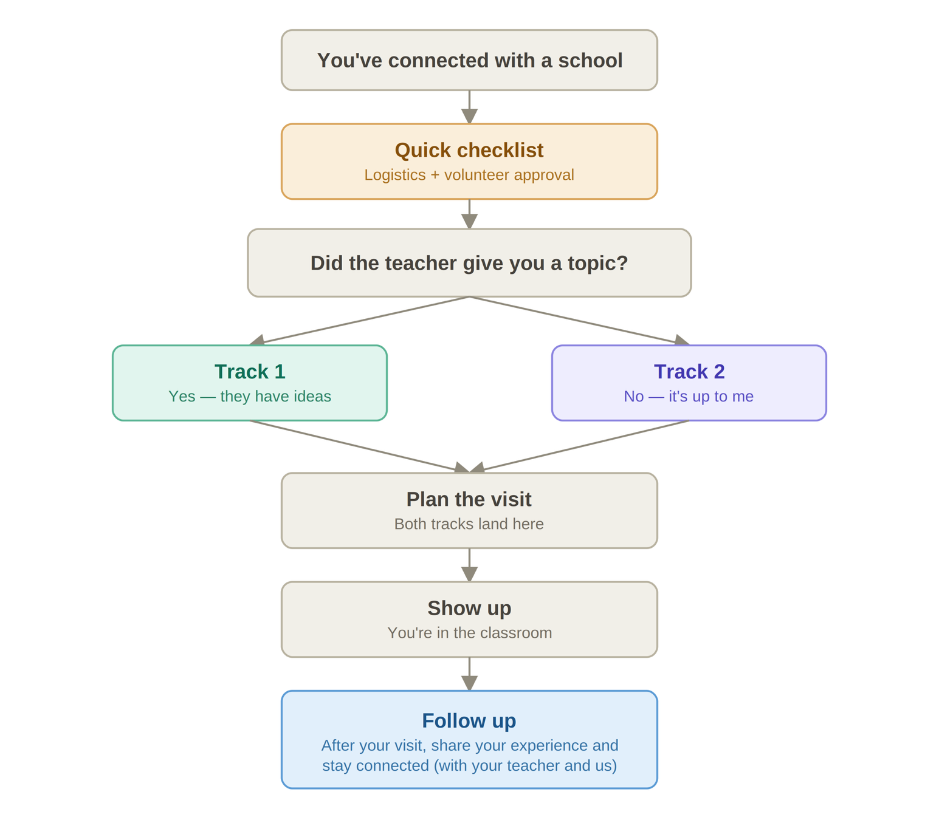

Which track are you on?
Pick your planning track below. Both lead to the same place — walking in ready to inspire. Whichever track you’re on, your lesson should teach at least two of the core constitutional ideas.
Track 1: Teacher has a lesson or ideas already
The hardest decision is already made. Your job is to run with it.
- Confirm the lesson, topic, and grade. Get the specifics — the exact lesson or topic, grade level, and how long you’ll have. In writing, if you can.
- Skim it and gather materials. Pick a single ready-to-run lesson from the Constitution Day Curriculum Library or Lesson Toolkit that aligns (or ask the teacher to share) and note anything to prepare or print. Be sure to land at least two core Constitutional ideas.
- Map it onto the period. Slot the lesson's activity into Part 4 — the main event — and build the rest of the class period around it. See Your visit at-a-glance.
- Prep and confirm logistics. Confirm room, timing, and AV needs (projector, screen, speakers) with the teacher — and if mock trial's part of your visit, start earlier: scripts and role assignments need lead time. Then build your full presentation, from opening hook to closing takeaway — don't wing it. See Visit Agenda & Tips.
Track 2: You have free range
A blank page feels bigger than it is. Here’s how to decide quickly and not overthink it.
- Pick your grade band and format. Think about which age group excites you and what kind of session you'd enjoy running — an activity, a discussion, or a read-aloud. (Step 1 of the Volunteer Toolkit can help if you’re undecided.)
- Choose one lesson from the library. Pick a single ready-to-run lesson from the Curriculum Library or Lesson Toolkit that fits your grade and lands at least two core Constitutional ideas.
- Run it by the teacher. A quick check-in early on goes a long way: "I'm thinking of [lesson] — does that work for your class?" It's their room, and a quick confirmation avoids surprises.
- Map it onto the period. Drop your chosen activity into Part 4 — the main event — and build the rest of the class period around it. See Your visit at-a-glance.
- Prep and confirm logistics. Confirm room, timing, and AV needs (projector, screen, speakers) with the teacher — and if mock trial's part of your visit, start earlier: scripts and role assignments need lead time. Then build your full presentation, from opening hook to closing takeaway — don't wing it. See Visit Agenda & Tips.

